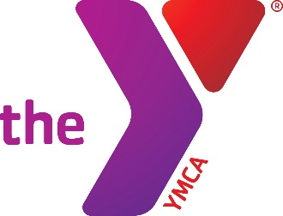
VOLUNTEER INSTRUCTIONS – YOUTH AND GOVERNMENT & MODEL UNITED NATIONS
The Volunteer Matters portal streamlines ways you volunteer with the YMCA and tracks your hours for your company or school.
The system simplifies the volunteer’s interactions with the Y and helps us better track all the great work you are doing on our behalf.

- To Register yourself as a YMCA Volunteer, you will create a Profile:
  - Go to: https://ymcadallas.volunteermatters.org
  - Click Register Now
  - Complete the Application and Submit
  - Login with Credentials
  - Sign our Policies and Save

- To Sign up for YG-MUN Volunteer Positions
  - If you wish to evaluate or judge for Judicial or Legislative at District Conference, or to send to a contact you know that would love to help out at District Conference, click here: Youth and Government District Conference Volunteers and sign up for a shift!
  - For Section Leaders, scroll down and sign up for the position.

Thank you for volunteering with the Y! You're a part of a dynamic, diverse network of cause-driven neighbors dedicated to strengthening the foundations of community. Thank you for being a part of this important work—together, we’re building a better us.
Sincerely,

YMCA of Metropolitan Dallas

